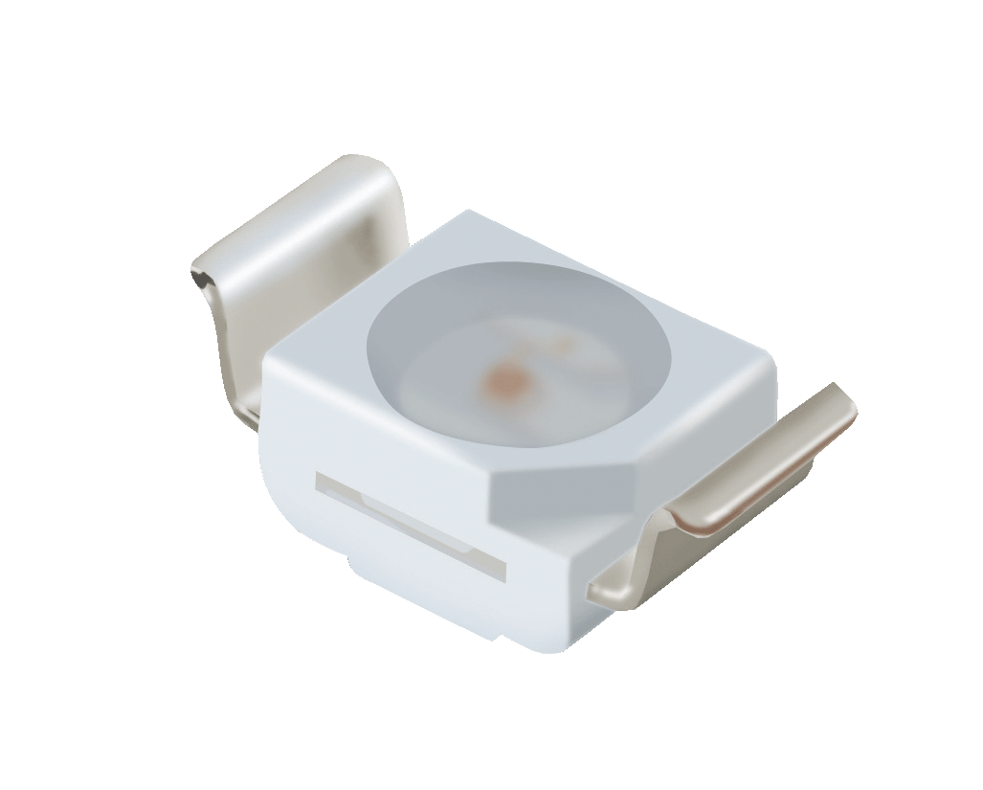
Features
․P-LCC-2 package.
․White package.
․Optical indicator.
․Colorless clear window.
․Wide viewing angle.
․Suitable for vapor-phase reflow, Infrared reflow
and wave solder processes.
․Computable with automatic placement equipment.
․Available on tape and reel (12mm Tape).
․Pb-free.
․ESD Protection.
․The product itself will remain within RoHS
compliant version
Descriptions
․The 67-11 series is available in soft orange, green,blue and yellow. Due to the package design, the LED has wide viewing angle and optimized light coupling by inter reflector. This feature makes the Top View LEDs ideal for light pipe application. The low current requirement makes this device ideal for portable equipment or any other application where power is at a premium.
Applications
․Telecommunication: indicator and backlighting in
telephone and fax.
․Flat backlight for LCD, switch and symbol.
․Light pipe application.
․General use.
Device Selection Guide
Chip | Emitted Color | Resin Color
Material | Emitted Color | Resin Color
InGaN | White | Water Clear

Package Dimensions

Notes: The tolerances unless mentioned is ±0.1mm; Unit = mm
Absolute Maximum Ratings (Ta=25℃)
Parameter | Symbol | Rating | Unit
Reverse Voltage | V_{R} | 5 | V
Forward Current | I_{F} | 30 | mA
Peak Forward Current (Duty 1/10 @1KHz) | I_{FP} | 100 | mA
Power Dissipation | Pd | 110 | mW
Electrostatic Discharge(HBM) | ESD | 2000 | V
Operating Temperature | Topr | -40 ~ +85 | ℃
Storage Temperature | Tstg | -40 ~ +90 | ℃
Soldering Temperature | Tsol | Reflow Soldering : 260 ℃ for 10 sec.  Hand Soldering : 350 ℃ for 3 sec.

Electro-Optical Characteristics (Ta=25℃)
Parameter | Symbol | Min. | Typ. | Max. | Units | Condition
Luminous Intensity | I_{V} | 450 | -- | 1120 | mcd | I_{F}=20mA
Viewing Angle | 2θ1/2 | -- | 120 | -- | deg | I_{F}=20mA
Forward Voltage | V_{F} | 2.75 | -- | 3.95 | V | I_{F}=20mA
Reverse Current | I_{R} | -- | -- | 50 | μA | V_{R}=5V
Notes:
1.Tolerance of Luminous Intensity: ±11%
2.Tolerance of Forward Voltage: ±0.05V

Bin Range of Luminous Intensity
Bin Code | Min. | Max. | Unit | Condition
U1 | 450 | 565 | mcd | I_{F}=20mA
U2 | 565 | 715 | mcd | I_{F}=20mA
V1 | 715 | 900 | mcd | I_{F}=20mA
V2 | 900 | 1120 | mcd | I_{F}=20mA

Bin Range of Forward Voltage
Group | Bin Code | Min. | Max. | Unit | Condition
M | 5 | 2.75 | 3.05 | V | I_{F}=20mA
M | 6 | 3.05 | 3.35 | V | I_{F}=20mA
M | 7 | 3.35 | 3.65 | V | I_{F}=20mA
M | 8 | 3.65 | 3.95 | V | I_{F}=20mA
Notes:
1.Tolerance of Luminous Intensity: ±11%
2.Tolerance of Forward Voltage: ±0.05V
Bin Range of Chromaticity Coordinate
Group | Bin Code | CIE_x | CIE_y | Bin Code | CIE_x | CIE_y | Condition
E | A0 | 0.280 | 0.248 | B3 | 0.287 | 0.295 | I_{F} =20mA
E | A0 | 0.264 | 0.267 | B3 | 0.283 | 0.305 | I_{F} =20mA
E | A0 | 0.283 | 0.305 | B3 | 0.304 | 0.330 | I_{F} =20mA
E | A0 | 0.296 | 0.276 | B3 | 0.307 | 0.315 | I_{F} =20mA
E | B4 | 0.307 | 0.315 | B5 | 0.296 | 0.276 | I_{F} =20mA
E | B4 | 0.304 | 0.33 | B5 | 0.287 | 0.295 | I_{F} =20mA
E | B4 | 0.33 | 0.36 | B5 | 0.307 | 0.315 | I_{F} =20mA
E | B4 | 0.33 | 0.339 | B5 | 0.311 | 0.294 | I_{F} =20mA
E | B6 | 0.311 | 0.294 |  |  |  | I_{F} =20mA
E | B6 | 0.307 | 0.315 |  |  |  | I_{F} =20mA
E | B6 | 0.330 | 0.339 |  |  |  | I_{F} =20mA
E | B6 | 0.330 | 0.318 |  |  |  | I_{F} =20mA
Notes: Tolerance of Chromaticity Coordinates : ±0.01

The C.I.E. 1931 Chromaticity Diagram
Typical Electro-Optical Characteristics Curves
Label Explanation
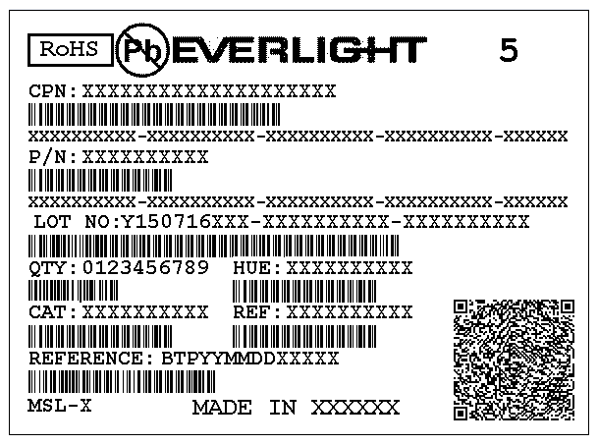
CAT: Luminous Intensity Rank
HUE: Dom. Wavelength Rank
REF: Forward Voltage Rank

Reel Dimensions

Note: Tolerance unless mentioned is ±0.1mm; Unit = mm

Carrier Tape Dimensions: Loaded Quantity 2000 pcs Per Reel.
Note: Tolerance unless mentioned is ±0.1mm; Unit = mm

Moisture Resistant Packaging

Precautions for Use

1. Over-current-proof
1.1 Customer must apply resistors for protection, otherwise slight voltage shift will cause big
current change ( Burn out will happen ).

2. Storage
2.1 Moisture proof bag should only be opened immediately prior to usage.
2.2 Environment should be less than 30℃ and 60% RH when moisture proof bag is opened.
2.3 After opening the package MSL Conditions stated on page 1 of this spec should not be exceeded.
2.4 If the moisture sensitivity card indicates higher than acceptable moisture, the component should
be baked at min. 60deg +/-5deg for 24 hours.

3. Soldering Condition
3.1 Pb-free solder temperature profile
3.2 Reflow soldering should not be done more than two times.
3.3 When soldering, do not put stress on the LEDs during heating.
3.4 After soldering, do not warp the circuit board.

4. Soldering Iron
Each terminal is to go to the tip of soldering iron temperature less than 350℃ for 3 seconds within
once in less than the soldering iron capacity 25W. Leave two seconds and more intervals, and do
soldering of each terminal. Be careful because the damage of the product is often started at the time
of the hand solder.

5. Repairing
Repair should not be done after the LEDs have been soldered. When repairing is unavoidable, a
double-head soldering iron should be used (as below figure). It should be confirmed beforehand
whether the characteristics of the LEDs will or will not be damaged by repairing.

Application Restrictions

High reliability applications such as military/aerospace, automotive safety/security systems,
and medical equipment may require different product. If you have any concerns, please contact
Everlight before using this product in your application. This specification guarantees the quality
and performance of the product as an individual component. Do not use this product beyond the
specification described in this document.

DISCLAIMER

- EVERLIGHT reserves the right(s) on the adjustment of product material mix for the specification.
- The product meets EVERLIGHT published specification for a period of twelve (12) months from date of shipment.
- The graphs shown in this datasheet are representing typical data only and do not show guaranteed values.
- When using this product, please observe the absolute maximum ratings and the instructions for using outlined in these specification sheets. EVERLIGHT assumes no responsibility for any damage resulting from the use of the product which does not comply with the absolute maximum ratings and the instructions included in these specification sheets.
- These specification sheets include materials protected under copyright of EVERLIGHT. Reproduction in any form is prohibited without obtaining EVERLIGHT’s prior consent.
- This product is not intended to be used for military, aircraft, automotive, medical, life sustaining or life saving applications or any other application which can result in human injury or death. Please contact authorized Everlight sales agent for special application request.
Revision History

Rev. | Modified date | File modified contents
1 | 2016.08.26 | New Spec
2 | 2016.11.25 | To add the Disclaimer

