Technical Data Sheet
TOP View LEDs

67-21UBC/C430/TR8

Features
․P-LCC-2 package.
․White package.
․Optical indicator.
․Colorless clear window.
․Wide viewing angle.
․Suitable for vapor-phase reflow, Infrared reflow
and wave solder processes.
․Computable with automatic placement equipment.
․Available on tape and reel (8mm Tape).
․Pb-free.
․The product itself will remain within RoHS
compliant version
Descriptions
․The 67-21 series is available in soft orange, green,blue and yellow. Due to the package design, the LED has wide viewing angle and optimized light coupling by inter reflector. This feature makes TOP LED ideal for light pipe application. The low current requirement makes this device ideal for portable equipment or any other application where power is at a premium.
Applications
․Automotive: backlighting in dashboard and switch.
․Telecommunication: indicator and backlighting in
telephone and fax.
․Flat backlight for LCD, switch and symbol.
․Light pipe application.
․General use.

Device Selection Guide
Chip |  | Lens Color
Material | Emitted Color | Lens Color
GaN/SiC | Purplish Blue | Water Clear

67-21UBC/C430/TR8
Package Dimensions
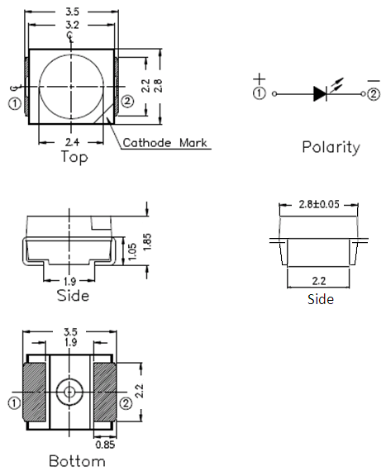

Notes: .All dimensions are in millimeters

67-21UBC/C430/TR8
Absolute Maximum Ratings (Ta=25℃)
Parameter | Symbol | Rating | Unit
Reverse Voltage | VR | 5 | V
Forward Current | IF | 30 | mA
Operating Temperature | Topr | -40 ~ +85 | ℃
Storage Temperature | Tstg | -40~ +100 | ℃
Electrostatic Discharge(HBM) | ESD | 1000 | V
Power Dissipation | Pd | 130 | mW
Peak Forward Current (Duty 1/10 @ 1KHZ) | I_{FP} | 70 | mA
Soldering Temperature | Tsol | Reflow Soldering : 260 ℃ for 10 sec.  Hand Soldering : 350 ℃ for 3 sec.
Electro-Optical Characteristics (Ta=25℃)
Parameter | Symbol | Min. | Typ. | Max. | Unit | Condition
Luminous Intensity | Iv | 36 | ----- | ----- | mcd | IF=20mA
Viewing Angle | 2θ1/2 | ----- | 120 | ----- | deg | IF=20mA
Peak Wavelength | λp | ----- | 428 | ----- | nm | IF=20mA
Dominant Wavelength | λd | 460.5 | ----- | 471.5 | nm | IF=20mA
Spectrum Radiation Bandwidth | △λ | ----- | 65 | ----- | nm | IF=20mA
Forward Voltage | Vf | 2.5 | ----- | 4.0 | V | IF=20mA
Reverse Current | IR | ----- | ----- | 50 | μA | VR=5V
Notes:
1.Tolerance of Luminous Intensity ±11%
2.Tolerance of Dominant Wavelength ±1nm
3.Tolerance of Forward Voltage ±0.1V

67-21UBC/C430/TR8
Typical Electro-Optical Characteristics Curves

67-21UBC/C430/TR8
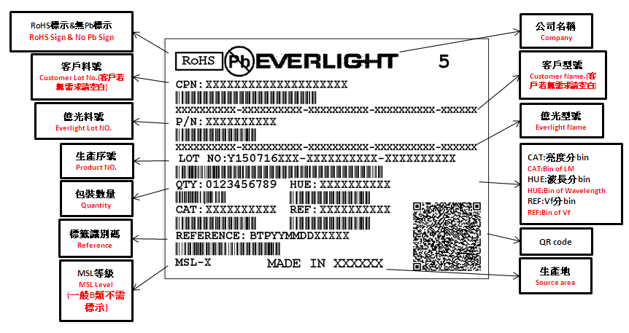
Label explanation
CAT: Luminous Intensity Rank
HUE: Dom. Wavelength Rank
REF: Forward Voltage Rank

Reel Dimensions

Note: The tolerances unless mentioned is ±0.1mm ,Unit = mm

67-21UBC/C430/TR8

Carrier Tape Dimensions: Loaded quantity 2000 PCS per reel.

Note: The tolerances unless mentioned is ±0.1mm

Moisture Resistant Packaging

67-21UBC/C430/TR8
Reliability Test Items And Conditions
The reliability of products shall be satisfied with items listed below.
Confidence level：90%
LTPD：10%
No. | Items | Test Condition | Test Hours/Cycles | Sample Size | Ac/Re
1 | Reflow Soldering | Temp. : 260℃±5℃ Min. 5sec. | 6 Min. | 22 PCS. | 0/1
2 | Temperature Cycle | H : +100℃ 15min  ∫ 5 min  L : -40℃ 15min | 300 Cycles | 22 PCS. | 0/1
3 | Thermal Shock | H : +100℃ 5min  ∫ 10 sec  L : -10℃ 5min | 300 Cycles | 22 PCS. | 0/1
4 | High Temperature Storage | Temp. : 100℃ | 1000 Hrs. | 22 PCS. | 0/1
5 | Low Temperature Storage | Temp. : -40℃ | 1000 Hrs. | 22 PCS. | 0/1
6 | DC Operating Life | IF = 20 mA | 1000 Hrs. | 22 PCS. | 0/1
7 | High Temperature / High Humidity | 85℃/ 85%RH | 1000 Hrs. | 22 PCS. | 0/1

67-21UBC/C430/TR8

Precautions For Use
1. Over-current-proof
Customer must apply resistors for protection , otherwise slight voltage shift will cause big
current change ( Burn out will happen ).
2. Storage
2.1 Do not open moisture proof bag before the products are ready to use.
2.2 Before opening the package, the LEDs should be kept at 30℃ or less and 90%RH or less.
2.3 The LEDs should be used within a year.
2.4 After opening the package, the LEDs should be kept at 30℃ or less and 70%RH or less.
2.5 The LEDs should be used within 168 hours (7 days) after opening the package.
2.6 If the moisture absorbent material (silica gel) has faded away or the LEDs have exceeded the
storage time, baking treatment should be performed using the following conditions.
Baking treatment : 60±5℃ for 24 hours.

3. Soldering Condition
3.1 Pb-free solder temperature profile
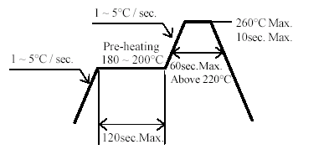
3.2 Reflow soldering should not be done more than two times.
3.3 When soldering, do not put stress on the LEDs during heating.
3.4 After soldering, do not warp the circuit board.

4.Soldering Iron
Each terminal is to go to the tip of soldering iron temperature less than 350℃ for 3 seconds within once in less than the soldering iron capacity 25W. Leave two seconds and more intervals, and do soldering of each terminal. Be careful because the damage of the product is often started at the time of the hand solder

67-21UBC/C430/TR8
5.Repairing
Repair should not be done after the LEDs have been soldered. When repairing is unavoidable, a double-head soldering iron should be used (as below figure). It should be confirmed beforehand whether the characteristics of the LEDs will or will not be damaged by repairing.

DISCLAIMER

- EVERLIGHT reserves the right(s) on the adjustment of product material mix for the specification.
- The product meets EVERLIGHT published specification for a period of twelve (12) months from date of shipment.
- The graphs shown in this datasheet are representing typical data only and do not show guaranteed values.
- When using this product, please observe the absolute maximum ratings and the instructions for using outlined in these specification sheets. EVERLIGHT assumes no responsibility for any damage resulting from the use of the product which does not comply with the absolute maximum ratings and the instructions included in these specification sheets.
- These specification sheets include materials protected under copyright of EVERLIGHT. Reproduction in any form is prohibited without obtaining EVERLIGHT’s prior consent.
- This product is not intended to be used for military, aircraft, automotive, medical, life sustaining or life saving applications or any other application which can result in human injury or death. Please contact authorized Everlight sales agent for special application request.

EVERLIGHT ELECTRONICS CO., LTD. Tel: 886-2-2267-2000, 2267-9936

Office: No 25, Lane 76, Sec 3, Chung Yang Rd, Fax: 886-2267-6244, 2267-6189, 2267-6306

Tucheng, Taipei 236, Taiwan, R.O.C http://www.everlight.com

