Technical Data Sheet
White SMD Surface Mount Device

67-11/W1C-FV1W2F/2T

Features
˙Fluorescence Type
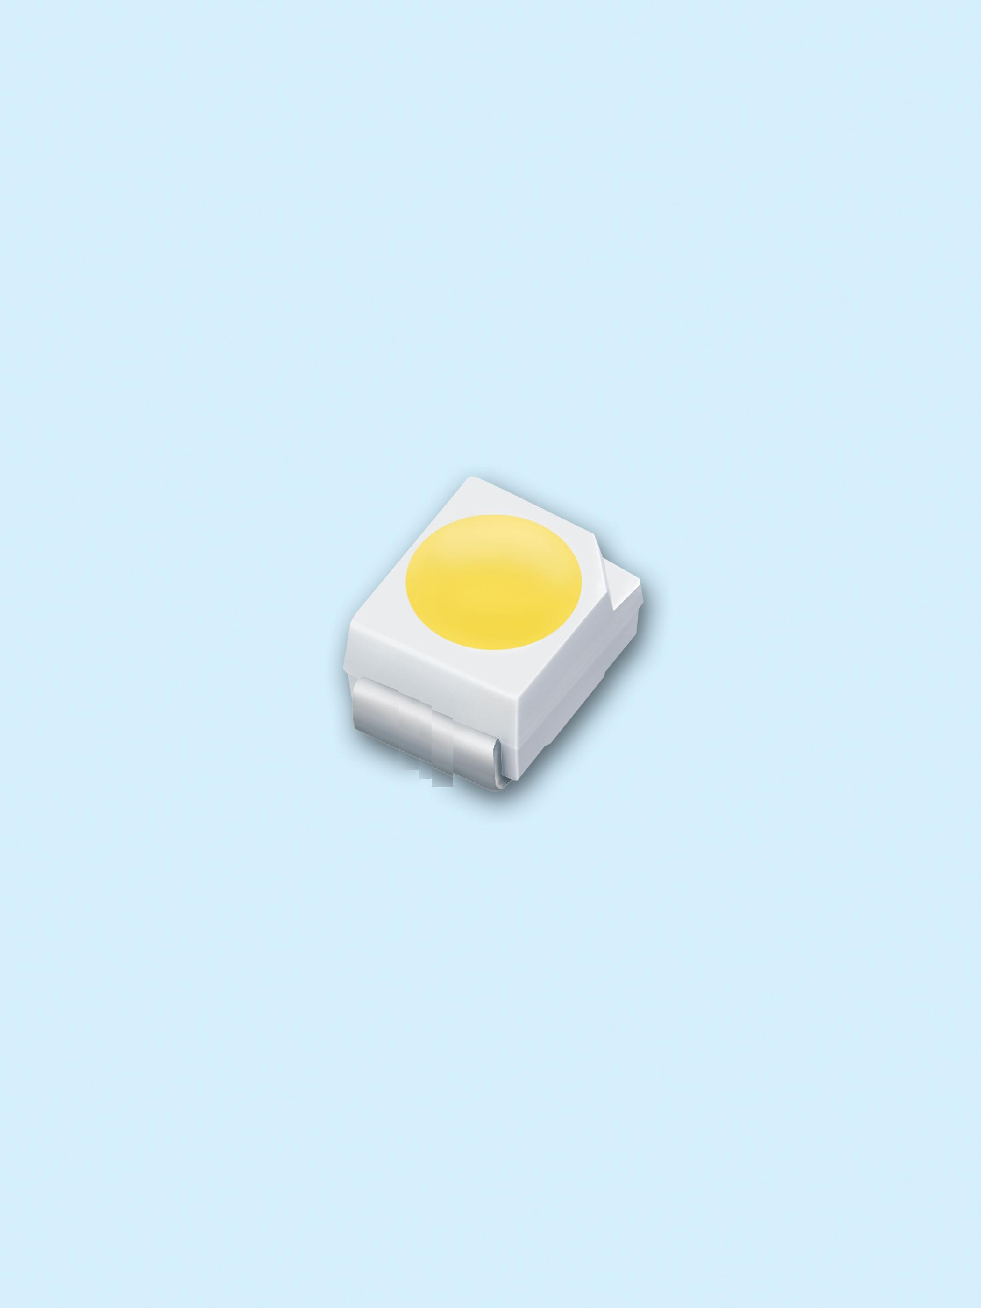
․High Luminous Intensity
․High Efficiency
․Emission Color:x=0.29,y=0.30
․Pb free
․The product itself will remain within RoHS
compliant version.
․ESD protection.

Descriptions
The white LED which was fabricated using a blue LED and a phosphor, and the phosphor is excited by blue light and emits yellow fluorescence. The mixture of blue light and yellow light results in a white emission.

Applications
․OA Equipment
․Backlighting of Full Color LCD
․Automotive Equipment
․Replacement of Conventional Light
Bulbs and Fluorescent Lamps

Device Selection Guide
Chip |  | Resin Color
Material | Emitted Color | Resin Color
InGaN | White | Water Clear

67-11/W1C-FV1W2F/2T
Package Dimensions
Note: The tolerances unless mentioned is ±0.1mm ,Unit = mm

67-11/W1C-FV1W2F/2T
Absolute Maximum Ratings (Ta=25℃)
Parameter | Symbol | Rating | Unit
Reverse Voltage | VR | 5 | V
Forward Current | IF | 25 | mA
Operating Temperature | Topr | -40 ~ +85 | ℃
Storage Temperature | Tstg | -40 ~ +90 | ℃
Electrostatic Discharge(HBM) | ESD | 2000 | V
Power Dissipation | Pd | 110 | mW
Peak Forward Current (Duty 1/10 @1KHz) | IFP | 100 | mA
Soldering Temperature | Tsol | Reflow Soldering : 260 ℃ for 10 sec.  Hand Soldering : 350 ℃ for 3 sec.
Electro-Optical Characteristics (Ta=25℃)
Parameter | Symbol | Min. | Typ. | Max. | Units | Condition
Luminous Intensity | I_{V} | 715 | ------ | 1800 | mcd | I_{F}=20mA
Forward Voltage | V_{F} | 2.70 | ----- | 3.50 | V | I_{F}=20mA
Viewing Angle | 2θ1/2 | -- | 120 | -- | deg | I_{F}=20mA
Notes:
1.Tolerance of Luminous Intensity ±10%
2.Tolerance of Forward Voltage ±0.1V

67-11/W1C-FV1W2F/2T
Bin Range Of Luminous Intensity
Bin Code | Min. | Max. | Unit | Condition
V1 | 715 | 900 | mcd | IF=20mA
V2 | 900 | 1120 | mcd | IF=20mA
W1 | 1120 | 1420 | mcd | IF=20mA
W2 | 1420 | 1800 | mcd | IF=20mA

Bin Range Of Forward Voltage
Group | Bin Code | Min. | Max. | Unit | Condition
F | 10 | 2.70 | 2.90 | V | IF=20mA
F | 11 | 2.90 | 3.10 | V | IF=20mA
F | 12 | 3.10 | 3.30 | V | IF=20mA
F | 13 | 3.30 | 3.50 | V | IF=20mA
Notes:
1.Tolerance of Luminous Intensity ±10%
2.Tolerance of Forward Voltage ±0.1V

67-11/W1C-FV1W2F/2T

Group | Bin Code | CIE_x | CIE_y | Bin Code | CIE_x | CIE_y
F | B3 | 0.287 | 0.295 | B4 | 0.307 | 0.315
F | B3 | 0.283 | 0.305 | B4 | 0.304 | 0.33
F | B3 | 0.304 | 0.330 | B4 | 0.33 | 0.36
F | B3 | 0.307 | 0.315 | B4 | 0.33 | 0.339
F | B5 | 0.296 | 0.276 | B6 | 0.311 | 0.294
F | B5 | 0.287 | 0.295 | B6 | 0.307 | 0.315
F | B5 | 0.307 | 0.315 | B6 | 0.330 | 0.339
F | B5 | 0.311 | 0.294 | B6 | 0.330 | 0.318
*The C.I.E. 1931 chromaticity diagram ( Tolerance ±0.01).

67-11/W1C-FV1W2F/2T
Typical Electro-Optical Characteristics Curves

67-11/W1C-FV1W2F/2T

Label Explanation
CAT: Luminous Intensity Rank
HUE: Chromaticity Coordinates
REF: Forward Voltage Rank

Reel Dimensions

Note: The tolerances unless mentioned is ±0.1mm ,Unit = mm

67-11/W1C-FV1W2F/2T

Carrier Tape Dimensions: Loaded quantity 2000 PCS per reel.

Note: The tolerances unless mentioned is ±0.1mm ,Unit = mm

Moisture Resistant Packaging

67-11/W1C-FV1W2F/2T

Reliability Test Items and Conditions
The reliability of products shall be satisfied with items listed below.
Confidence level：90%
LTPD：10%
No. | Items | Test Condition | Test Hours/Cycles | Sample Size | Ac/Re
1 | Reflow Soldering | Temp. : 260℃±5℃  Min. 5sec. | 6 min | 22 PCS. | 0/1
2 | Temperature Cycle | H : +100℃ 15min  ∫ 5 min  L : -40℃ 15min | 300 Cycles | 22 PCS. | 0/1
3 | Thermal Shock | H : +100℃ 5min  ∫ 10 sec  L : -10℃ 5min | 300 Cycles | 22 PCS. | 0/1
4 | High Temperature Storage | Temp. : 100℃ | 1000 Hrs. | 22 PCS. | 0/1
5 | Low Temperature Storage | Temp. : -40℃ | 1000 Hrs. | 22 PCS. | 0/1
6 | DC Operating Life | IF = 20 mA / 25℃ | 1000 Hrs. | 22 PCS. | 0/1
7 | High Temperature / High Humidity | 85℃/ 85%RH | 1000 Hrs. | 22 PCS. | 0/1

67-11/W1C-FV1W2F/2T

Precautions for Use
1. Over-current-proof
Customer must apply resistors for protection, otherwise slight voltage shift will cause big
current change ( Burn out will happen ).
2. Storage
2.1 Do not open moisture proof bag before the products are ready to use.
2.2 Before opening the package: The LEDs should be kept at 30℃ or less and 90%RH or less.
2.3 After opening the package: The LED's floor life are 72 hours under 30℃ or less and 60% RH or less. If unused LEDs remain, it should be stored in moisture proof packages.
2.4 If the moisture absorbent material (silica gel) has faded away or the LEDs have exceeded the
storage time, baking treatment should be performed using the following conditions.
Baking treatment : 60±5℃ for 24 hours.
3. Soldering Condition
3.1 Pb-free solder temperature profile
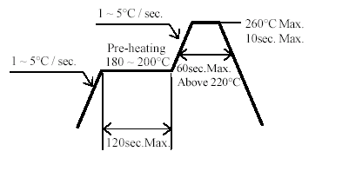
3.2 Reflow soldering should not be done more than two times.
3.3 When soldering, do not put stress on the LEDs during heating.
3.4 After soldering, do not warp the circuit board.
4.Soldering Iron
Each terminal is to go to the tip of soldering iron temperature less than 350℃ for 3 seconds within once in less than the soldering iron capacity 25W. Leave two seconds and more intervals, and do soldering of each terminal. Be careful because the damage of the product is often started at the time of the hand solder.

67-11/W1C-FV1W2F/2T
5.Repairing
Repair should not be done after the LEDs have been soldered. When repairing is unavoidable, a double-head soldering iron should be used (as below figure). It should be confirmed beforehand whether the characteristics of the LEDs will or will not be damaged by repairing.

DISCLAIMER

- EVERLIGHT reserves the right(s) on the adjustment of product material mix for the specification.
- The product meets EVERLIGHT published specification for a period of twelve (12) months from date of shipment.
- The graphs shown in this datasheet are representing typical data only and do not show guaranteed values.
- When using this product, please observe the absolute maximum ratings and the instructions for using outlined in these specification sheets. EVERLIGHT assumes no responsibility for any damage resulting from the use of the product which does not comply with the absolute maximum ratings and the instructions included in these specification sheets.
- These specification sheets include materials protected under copyright of EVERLIGHT. Reproduction in any form is prohibited without obtaining EVERLIGHT’s prior consent.
- This product is not intended to be used for military, aircraft, automotive, medical, life sustaining or life saving applications or any other application which can result in human injury or death. Please contact authorized Everlight sales agent for special application request.

EVERLIGHT ELECTRONICS CO., LTD. Tel: 886-2-2267-2000, 2267-9936

Office: No 25, Lane 76, Sec 3, Chung Yang Rd, Fax: 886-2267-6244, 2267-6189, 2267-6306

Tucheng, Taipei 236, Taiwan, R.O.C http://www.everlight.com

